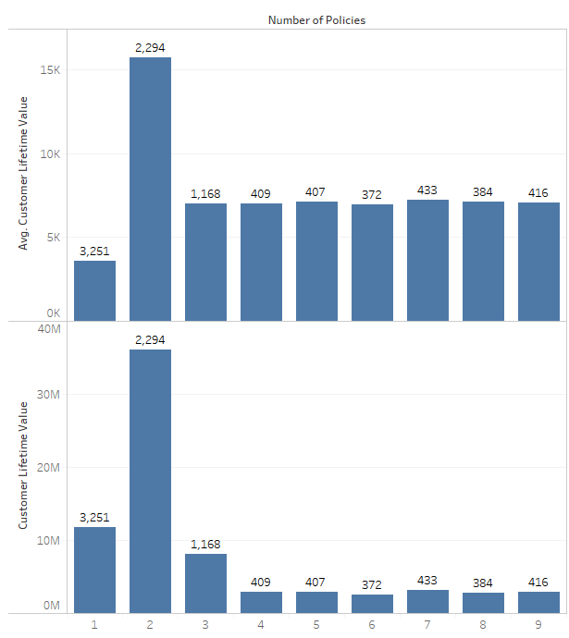

Customer with total policy 2 have large CLTV value compared with the rest.

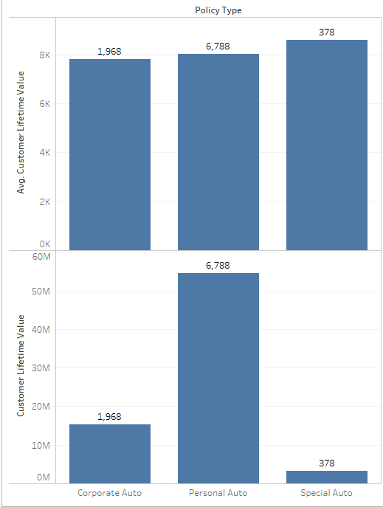

Customers with policy type personal auto have very large number. IF company increases its premium by small amout ,the profit can increase drastically

Average CLV of customers who have Monthly Premium auto between 210-240 rupees is higher than CLV of customers who have Monthly Premium between 60-90 rupees.

Average Income of customers who have Monthly Premium auto between 45450 rupees is higher than CLV of customers who have Monthly Premium between 37860 rupees.

Customers with Premium coverage have more avg.CLTV than customers with Basic and Extended coverage